**Name:محمد زكريا محمد عبد المقصود**

**b.n: 712**

**sec :32**

**group :6**

**github link:**

**puplished website:**

**topic : artificial intelligence**

# **application brief: I choose this topic (artificial intelligence) because it is the future and the next step in the technology and it is very important in many fields engineering ,medicine ,agriculture…….**

# **I think any country want to be great it should help their people to learn more about aI**

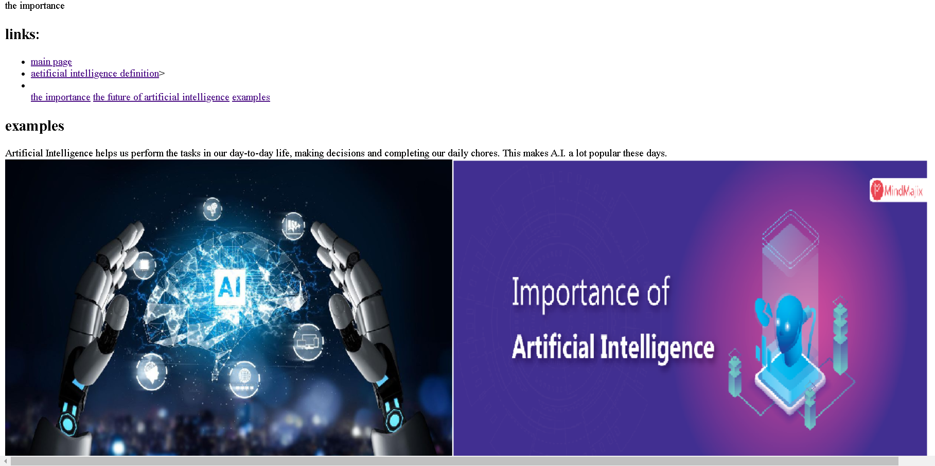

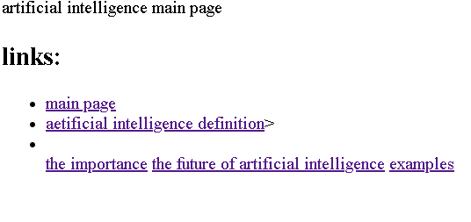

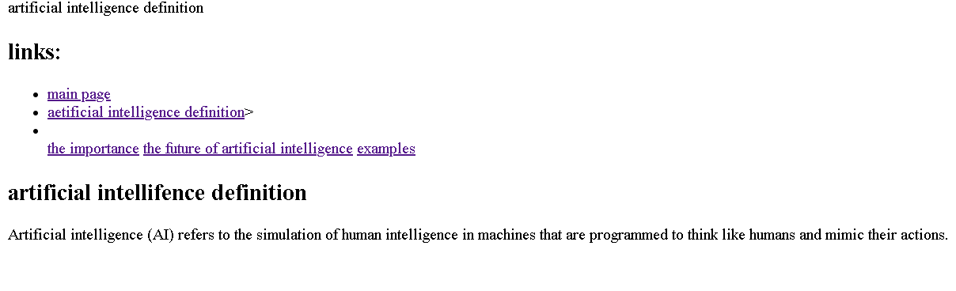

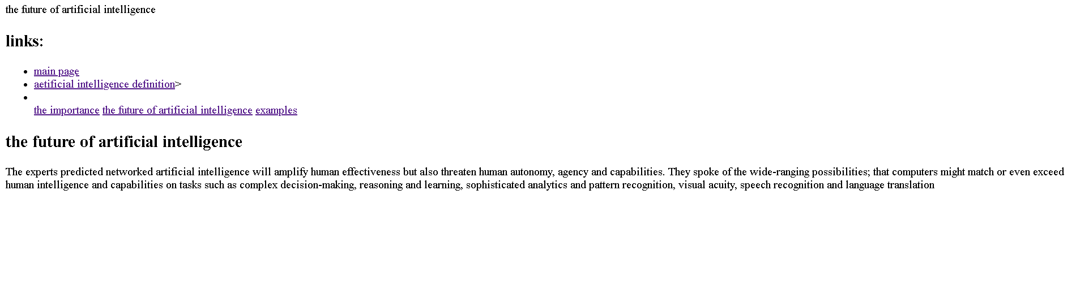

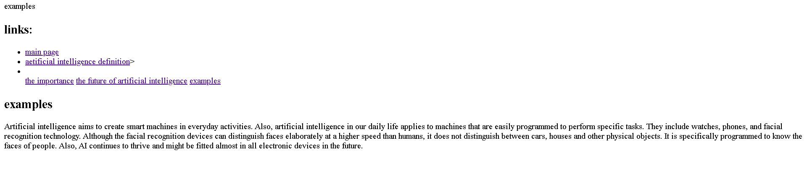

**Source code**

